**MOBILE PHONE RECOMMENDER USING MULTI CRITERIA DECISION MAKING ALGORITHM**

Prriyamvadhaa M A

Dept. of Information Technology

Rajalakshmi Engineering College

Chennai, India

Prriyamvadhaa.ma@gmail.com

Purushothaman U

Dept. of Information Technology

Rajalakshmi Engineering College

Chennai, India

Purushothaman24051999@gmail.com

Saadana S

Dept. of Information Technology

Rajalakshmi Engineering College

Chennai, India

Saadana.264@gmail.com

Babu R

Dept. of Information Technology

Rajalakshmi Engineering College

Chennai, India

Babu.r@rajalakshmi.edu.in

**ABSTRACT**

The best smartphones are hard to pick from the diverse brands available across the globe. It is a bewildering task to choose a smartphone that suits the criteria of the user. The goal of the project is to provide a list of smartphones that is best suited to the user criteria and make their work easier in choosing their perfect smartphone. The smartphones will be listed based on the filters provided by the users. The filters will have attributes like price, camera, OS, brands, ROM and RAM, etc. Each attribute of filters will have a priority table based on which suggestions will sorted form the highest to the lowest priority. AHP-weightage will be used to prioritize the attributes. The outcome of the project is in the form of a user-friendly website that gets inputs to form the user in the form of filters and provides the best ranking list of mobiles in a timely response. The project uses various MCDM (Multicriteria Decision Making) algorithms such as PROMOTHEE 1 and 2, TOPSIS for ranking the attributes based on AHP weightage and concludes which algorithms are best suited in terms of time and space efficiency.

**Keywords**— mobile suggestions, website, filters, MCDM algorithms, efficiency

**I. INTRODUCTION**

In the modern world, people are moving towards an easier method of online purchasing to limit their time spent on those tasks. To make it more comfortable for the customer's several commercial service providers are digitizing their domain of business. In today’s scenarios, several commercial websites for online shopping have emerged in the markets, which allows the customers to perform their shopping work online and their products are being delivered at the doorstep. This process has numerous advantages in regards to time-saving and marketing products at cheaper rates, but a question arises whether the customers who are searching for a particular product are being provided with appropriate services without diverting them from their original intention. In most of the websites in today’s modern market, it mentally forces the customers to buy the products which they are not originally needed. This proposed system, suggests implementing a commercial website for mobile phones which will enable the customers to search their required product without any kind of external diversion. This proposed system asks the customer to choose the filters for the particular product they want to purchase. Customers are also provided with an additional option of choosing the priorities for each filter so that the system may recommend the products which are more suited to them according to their priorities.

**II. RELATED WORKS**

Philip Achimugu et.al (2014) stated a system [1] is a web-based system that focuses on providing software requirements that are prioritized by the MCDM technique. The approach offers a brief way of involving stakeholders in the entire decision-making process irrespective of their position in an automatic fashion. The stakeholders select the project software requirements from the suggested optimal tool recommender. Thereby it promotes an efficient way of building an application. The system also is proposed to give an outcome that prioritizes the requirement with the graph showing the requirements in chronological order. The system never talks on user-specific needs but only provides a suggestion of optimal requirements to be used to build a project. Georges Adulin et.al (2014) proposed a model [2] that the systematic review and bibliometric analysis in healthcare have become important and lack the analysis in these areas. Thereby to systematically identify the applications and report on publication trends in healthcare, he proposed a system that involved optimal decision making of the search strategies. The search terms were used along with side the Boolean operators. Various reference lists of previously published reviews were identified and scrutinized for relevant citations. The trends were analysed. Various publishes of healthcare were identified by the year of publications, MCDA technique, type of intervention and application area. The systematic review thereby identified search results of about 205 publications, of these, some were duplicates and some didn’t meet the expected search criteria. Only the optimized searches were reviewed, reported and included. Further, he also stated that research is needed to develop practice guidelines for the appropriate application and reporting of MCDA methods. This approach may not be optimal where it produced many duplicate search results. Vijay Manikrao Athawale et.al (2010) Stated [3] that the location selection for a manufacturing industry is a tedious process. There are many attributes of alternatives involved such as resource, cost, production capacity, distribution network, etc. If any of these is less than the good scalability, then it leads to major loss to the organization. This method uses multi-criteria decision making PROMETHEE 2 algorithm to select the best manufacturing land. The heavy computational cost when a system requires a high model order operating on high dimensional data. Vahid Balali et.al (2012) Stated [4] that the process of constructing a structural system for a construction site is an overwhelming task for civil engineers. They need to take both technical and economic criteria for the construction of the best system. To choose the best construction site the best decision as to be made when the user provides the criteria needed for the best site. This paper has combined two multi-criteria decision techniques (electric 3 and PROMETHEE 2) and proposed a decision-making system with the aggregation of both the techniques. This proposed system helped in selecting the appropriate structural system. The system provided more than an accurate search result when searched.

Harry Barton et.al (2008) stated [5] that the police forces in the UK are periodically compared with each other on their performance, by government and non-government bodies. This study demonstrates the use of PROMETHEE in an investigation of the targeted performance rank improvement of individual UK police forces (with their ‘most similar forces’ groups). The graphical representations show an insight that the application of such a PROMETHEE based series provides an improvement analysis. The goals of this study are twofold, firstly to take advantage of PROMETHEE based uncertainty analysis in the rank improvement and secondly, how the next results can form a part of the evidence to assist in their performance strategies. No optimized decision making available. Darius Danesh et.al (2017) proposes a model [6] that the successful delivery of objectives of an organization, selection of project portfolios is important. They are different MCDM techniques to make a decision. This system uses hundreds of techniques and experimented with thousands of portfolios to pick a perfect project portfolios, after successful experimentation they narrowed down to eight suitable techniques such as analytic hierarchy process (AHP), analytic network process (ANP), data envelopment analysis (DEA), elimination and selection expressing the truth (ELECTRE), preference ranking organization method for enrichment evaluations (PROMETHEE), technique for order preference by similarity to ideal solution (TOPSIS), analytic hierarchy process (AHP), dominance-based rough set approach (DRSA), and VlseKriterijumska Optimizacija I Kompromisno Resenje (VIKOR)]. After repeated constructive review with these eight techniques, they concluded AHP and DEA are best suited to find the project portfolio helpful is maintaining the organization's objective. Only various techniques were provided optimal solution is yet to be achieved. Anissa Frini et.al (2012) stated a system [7] with the intensification of chronic disease within older people, concurrent use of different drugs (poly-pharmacy) is becoming increasingly frequent. However, there is no established manner to determine whether poly-pharmacy is appropriate or not. They propose an original method of classifying poly-pharmacy using multi-criteria decision-aid methods. To do this, they provided clinicians with a list of drugs that could be potentially prescribed to the typical elderly person suffering from three diseases (diabetes, chronic obstructive pulmonary disease, and heart failure). Clinicians expressed their opinion on a 5-point Likert scale, allowing for hesitation between two or more answers. They evaluated the risks, benefits, and impacts of each drug on the patient’s quality of life. They then aggregated these evaluations to get, for every drug, a multi-criteria evaluation vector representing the collective opinion of the clinicians consulted. Subsequently, ELECTRE Tri-C and ELECTRE Tri multi-criteria methods were used to evaluate and assign the poly-pharmacy to one of the following three categories: appropriate, more or less appropriate, or inappropriate. There were many Hesitation between two or more answers among the clinical experts. Majid Khalaji et.al (2012) stated a system [8] for a recommendation of E-commerce products. He mainly focused to style a Recommender System using association of complementary and similarity among goods and commodities and offer the only goods supported personal needs and interests. Also, the other purpose of this paper is to solve some problems, such as the old start and scalability. These problems are involved in many Recommender Systems. He also divided the system into many categories and solve the issues in a recommendation. The system moreover not focuses on one particular product and focuses on the similarities between them. The system has chances to divert the user from a specific task in choosing the product. Axel C. Muhlbacher et.al (2015) stated a system [9] that Healthcare decision making is a tedious task as it needs to cover the overall patient preferences, insures and experts involved. MCDA also needs to focus on local, national and international needs. He also states that MCDA provides transparency in healthcare decision making. MCDA provides more diversity of approaches and applications within specific healthcare situations. Various patient assessment levels and clinical endpoints are considered with an aim to generate patient-relevant benefit data of an intervention. They provide optimized results on what facilities the patients require, the expert needed to be based on MCDM. Expert selection by decision making has not been studied to date but could lead to interesting insights. Oses et.al (2018) stated a system [10] that It is a tedious process for any local government to improve urban transportation. Numerous criteria should be taken into account for improving sustainability. This paper used a multi-criteria decision-making algorithm to find an area that has weaker sustainability and improve them. However, this paper does not focus on the criteria that include the attributes of the cities which has a major impact on the decision-making process. The system does not focus on the criteria that include the attributes of the cities which has a major impact on the decision-making process.

Sharmistha Roy et.al (2018) stated a system [11] that E-commerce enables a firm or an individual to establish a market or enhance an existing market position over the internet, by providing an efficient business chain and low-cost product and service. Mr. Sharmistha Roy focuses on a comparative study of three main MCDM algorithm that provides basic results as per user needs and their interests in choosing a product from an E-Commerce web site. AHP decomposes the decision problem into criteria, sub-criteria, and alternative forming a hierarchy. PROMETHEE is another Multi-Criterion Decision-Making method that finds the best alternatives. TOPSIS ranks the choice supported the space between positive and negative ideal solution. Though he has proposed individual algorithms functioning. Combined analysis or providing an optimal solution without diverting the user interests are not satisfied. Abhishek Srivastava et.al (2017) stated a system [12] The paper decides the features that will help in designing the crash-free system. For deciding which criteria has the major weightage in the system crash scenario, it used a multi-criteria decision-making algorithm **- DEMATEL**. By using this it designed a system with fewer chances of getting a crash. Obtaining anOptimal solution is difficult. Patrick Taillandier et.al (2011) stated a model [13] that the exploration of an unknown environment by a robot system; an individual robot or a team of robots; is a well-studied problem in robotics. This problem mainly focuses on finding victims after a disaster. Most of the proposed exploration algorithms are supported by the utilization of specific criteria to define the standard of the possible movements. In this paper, the system proposes a search approach that supported the mixture of several criteria because of the PROMETHEE II multi-criteria deciding method. The PROMETHEE II method allows one to determine an entire ranking between possible movements supported outranking relations. Experimental results show that this approach is often wont to effectively combine different criteria and outperforms several classic exploration strategies. Obtaining anOptimal search solution is difficult when an individual algorithm is used. Ziming Zeng et.al (2010) Stated the system [14] that integrates semantic retrieval and multi-attribute decision method. First, semantic similarity is computed by constructing semantic vector-space, to understand the semantic consistency between retrieved results and customer’s query. Besides, the TOPSIS method is additionally utilized to construct the comparison mechanism of the commodity by calculating the utility value of every retrieved commodity. Finally, the experiment is conducted in terms of accuracy and customer acceptance rate, and therefore the results verify the effectiveness of the model and it can improve the precision of the commodity information search. A comparison mechanism with decision making has not been studied to date but could lead to interesting insights.Hongju Zhao et.al(2013) stated a system [15] To improve efficiency in a timely response, an experiment has been conducted by integrating multiple steps of traditional PROMETHEE into one formula so that it reduces computational complexity, comparisons, etc. A test is done by comparing the traditional PROMETHEE and modified PROMETHEE by providing the alternatives of an earthquake. The outcome of the test showed more efficiency in modified PROMETHEE. But the proposed method does not prove the influence of the size. Combined analysis or providing an optimal solution without diverting the user interests are not satisfied.

**III.PROPOSED SYSTEM**

The proposed system extracts the required criteria from the customer and the products are listed according to their needs. This system also provides a list of service providers who can provide a particular brand. Since it is implemented using MCDM algorithms it can avoid the user to encounter irrelevant products. fig (1)shows the user interface will be in the form of a commercial website. The user will be provided an option to enter the filters and assign weightage to individual attributes. The proposed system will provide suitable recommendations to the customer along with the various service provider as an additional suggestion.

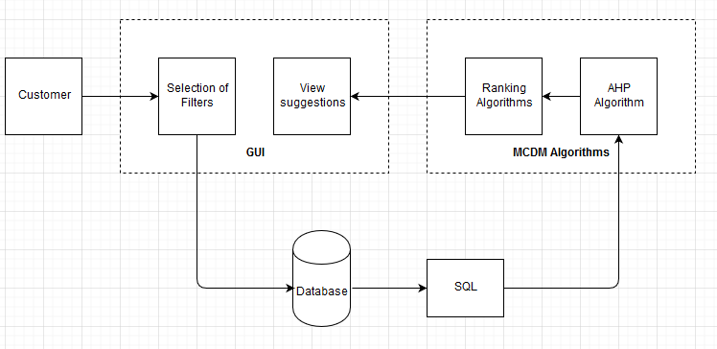

**fig (1): Detailed design for proposed system**

1. **GUI MODULE**

The graphical User Interface of the proposed system in fig (2), will provide sufficient options for the customer who are utilizing this system to select the filters according to their needs for smartphones. The customers can also provide weightage for each filter parameter. After a sequence of operations performed in the inner layer, the user can view the predicted recommendations based on their requirements. This system will also provide a list of service providers who can offer those products to the customers.

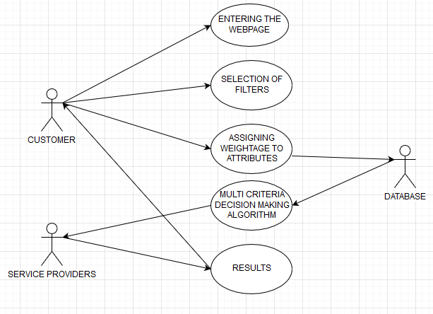

**fig (2): use case for GUI view**

1. **ALGORITHM OF OVERALL PROCESS**

When making decisions, decision-makers (DMs) always attempt to choose the optimal solution. Unfortunately, an optimal solution exists only in case of one single criterion; in real decision situations, almost any decision involves some conflicts or dissatisfaction. MCDM methods are to help people make their decision consistent with their preferences, in cases where there's quite one conflicting criterion, finding the optimal choice among the alternative.The system thereby works based on the categorisation of the weights that a user enters. The search starts based on the ranking the user specifies. The background works on the AHP algorithm to first search on the weight basis to show the result. The Promethee algorithm further ranks individual weights on which the user enters thereby picking up an optimal solution. The system provides an output of the most optimal search result finally

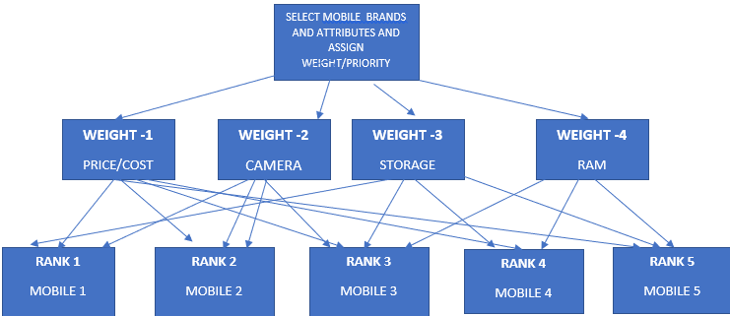

**fig (3): overview working result of AHP - ANALYTIC HIERARCHY PROCESS AND PROMETHEE ALGORITHM**

Analytical Hierarchy Process (AHP) is used to assign weightage to the attributes as shown in fig (3) which in turn is supplied as input to MCDM algorithms. PROMOTEE- 1 & 2 algorithms are usually used to rank the products based on the assigned weightage as shown infig (3). These ranks are usually used to arrange the products according to customer preferences.

Steps involved in of AHP-PROMETHEE is as follows:

Step1: Data Collection (mobile brands, price, camera, RAM, ROM,

display, processor, android version) User enters their specified data in the required fields.

Step2: Application of AHP (assigning weights and decision)   
The AHP algorithm provides a weight for each of the parameter the user enters. The further weightage-based filtering now takes place.

Step3: Application of PROMETHEE  
The PROMETHEE Algorithm is further designed to rank the items that user has entered according to their priority.

preference function comparison between attributes alternative comparison and criteria matrix partial ranking final ranking of mobiles

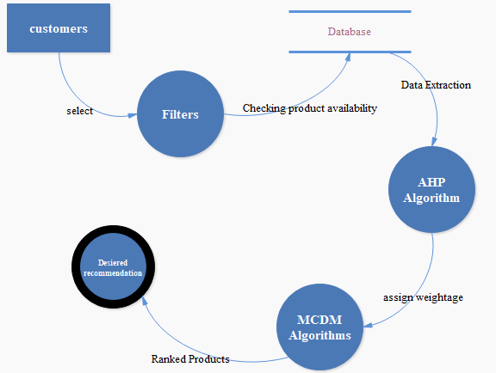

**fig (4): Dataflow diagram of the proposed system works**

The System flow in fig (4) describes the flow of processes in the system architecture which details the view of data flow from one component to another.

**C. ADVANTAGES OF PROPOSED SYSTEM**

• In the Existing System, the search results are obtained randomly based on the filter criteria.

• In the proposed system, the filter criteria are given a weightage through which the products are ranked.

**IV. RESULTS AND DISCUSSION**

The objective is to provide an integrated platform for the customers which enables them to search a particular product across different service providers. It enables the customer to view selected items based on their requirements. This platform will suggest several recommendations based on their priorities.The usage of weighted attributes in Multi-Criteria Decision Making (MCDM) Algorithms will rank the products based on the user’s expectation. This will make the user feel more comfortable and be precise while they are purchasing with the help of this proposed system’s recommendations.

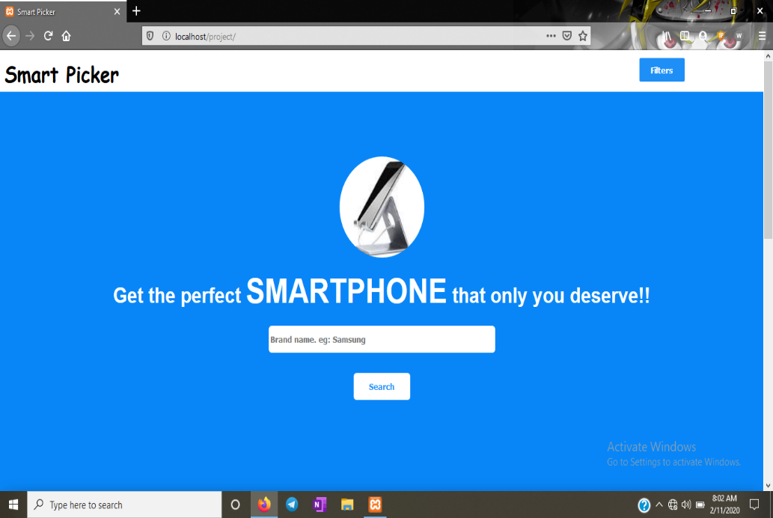

**fig (5): Home page of the mobile recommender site**

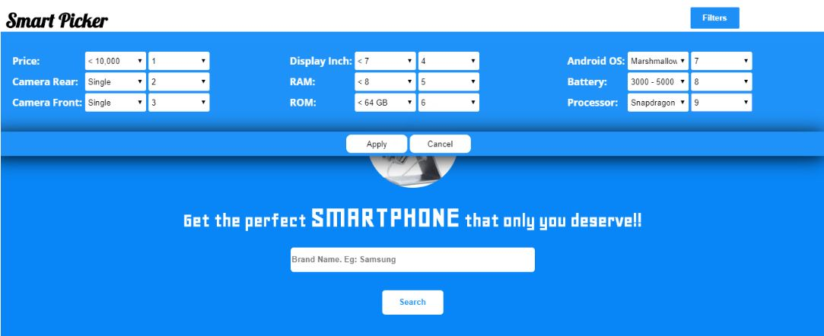

**fig (6): Depicts the User Search Filter Page where users can Search through the optimized attributes.**

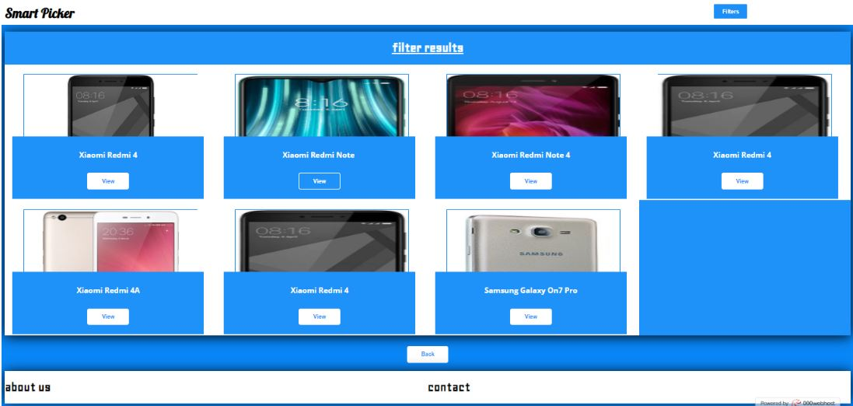

**fig (7): Represents the accurate search results.**

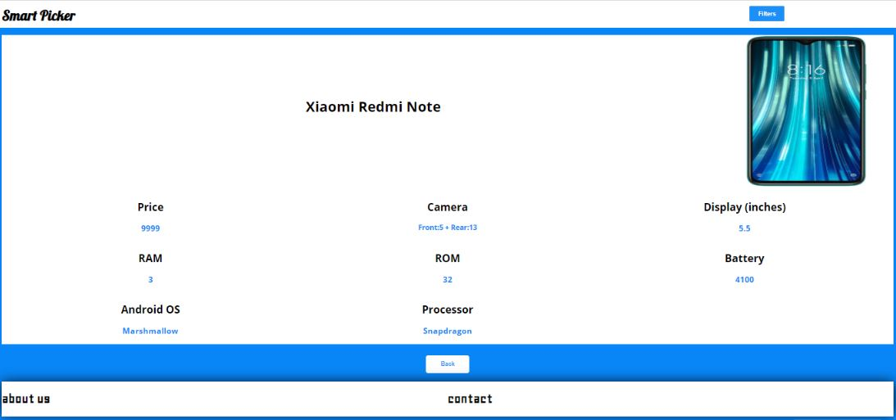

**fig (8): Represents the selected Mobile Phone with its features**

**V. CONCLUSION**

Advancement in search and filter methods has to check out parametric conditions and necessities of the user’s interest accurately for tomorrow. Maintaining and keeping up accuracy to a standard is always tougher and troublesome with time. Some of the challenges can be anticipated, such as advances in algorithmic conversions that are making it easier to provide accurate search results from the database. Here MCDM is being utilized to work around the basic shortcomings in user search results. As the confirm mechanism for searching our view could be suitable and accurately used. Similarly, we have also developed a system that does not allow any user from getting diverted from the search they wanted to perform.

**VI. REFERENCES**

[1] Achimugu, Philip &amp; Selamat, Ali &amp; Ibrahim, Roliana. (2014). ‘A Web-Based Multi-Criteria Decision-Making Tool for Software Requirements Prioritization’. 10.1007/978-3-319-11289-3_45.

[2] Adunlin, G., Diaby, V., &amp; Xiao, H. (2015). ‘Application of multicriteria decision analysis in healthcare: a systematic review and bibliometric analysis. Health expectations: an international journal of public participation in health care and health policy’, 18 6, 1894-905.

[3] Athawale, Vijay & Chakraborty, Shankar. (2010). ‘Facility Layout Selection Using PROMETHEE II Method’.

[4] Balali, Vahid & Zahraie, Banafsheh & Roozbahani, Abbas. (2012). ‘Integration of ELECTRE III and PROMETHEE II decision-making methods with an interval approach: Application in selection of appropriate structural systems. Journal of Computing in Civil Engineering’. 28. 297-314. 10.1061/(ASCE)CP.1943-5487.0000254.

[5] Beynon, Malcolm & Barton, Harry. (2008). ‘A PROMETHEE based uncertainty analysis of UK police force performance rank improvement. International Journal of Society Systems Science’. 1. 176-193. 10.1504/IJSSS.2008.021918.

[6] Danesh, Darius & Ryan, Mike & Abbasi, Alireza. (2017). ‘A Systematic Comparison of Multi-criteria Decision-Making Methods for the Improvement of Project Portfolio Management in Complex Organizations’. International Journal of Management and Decision Making. 16. 1. 10.1504/IJMDM.2017.10005690

[7] Frini, Anissa & Sirois, Caroline & Laroche, Marie-Laure. (2020). ‘A Hybrid Delphi Multi-criteria Sorting Approach for Polypharmacy Evaluations’. 10.1007/978-981-32-9808-8_22.

[8] Khalaji, Majid. (2012). ‘Improving Recommender Systems in E-Commerce Using Similar Goods’. Journal of Software Engineering and Applications. 05. 96-101. 10.4236/jsea.2012.52015.

[9] Mühlbacher, Axel &amp; Kaczynski, Anika. (2015). ‘Making Good Decisions in Healthcare with Multi-Criteria Decision Analysis: The Use, Current Research and Future Development of MCDA’. Applied health economics and health policy. 14. 10.1007/s40258-015-0203-4.

[10] Oses, U. & Roji, Eduardo & Cuadrado, J. & M., Larrauri. (2018). ‘Multiple-Criteria Decision-Making Tool for Local Governments to Evaluate the Global and Local Sustainability of Transportation Systems in Urban Areas: Case Study. Journal of Urban Planning and Development’. 144. 10.1061/(ASCE)UP.1943-5444.0000406.

[11] Roy, Sharmistha. (2018). ‘COMPARATIVE STUDY OF SOME MCDM TECHNIQUES FOR E-COMMERCE APPLICATIONS’. International Journal of Advanced Research in Computer Science. 9. 440-443. 10.26483/ijarcs. v9i1.5361.

[12] Srivastava, Abhishek & Singh, Bhakti & Chabra, Anshul & Majumdar,. (2017). ‘Application and use of MCDM technique in software industry’. 487-491. 10.1109/ICTUS.2017.8286058.

[13] P.Taillandier and S. Stinckwich, ‘Using the PROMETHEE multi-criteria decision making method to define new exploration strategies for rescue robots,’ 2011 IEEE International Symposium on Safety, Security, and Rescue Robotics*,* Kyoto, 2011, pp. 321-326.

[14] Zeng, Z. (2010). ‘A Commodity Information Search Model of E-Commerce Search Engine Based on Semantic Similarity and Multi-Attribute Decision Method.’

[15] Zhao, Hongju & Peng, Yi & Li, Wei. (2013). ‘Revised PROMETHEE II for improving efficiency in emergency response. Procedia Computer Science’. 17. 181–188. 10.1016/j.procs.2013.05.025.